**LAMBDA, DYNAMO DB, API GATEWAY, STEP FUNCTIONS & COGNITO**

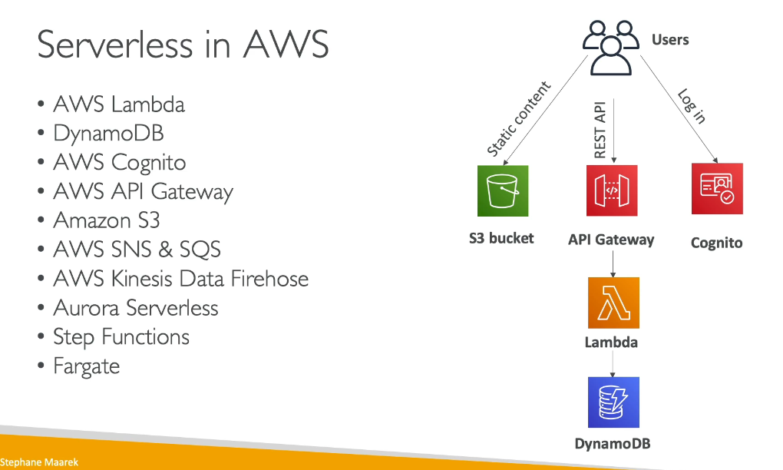

**AWS offers a wide range of serverless services across different categories:**

**Compute**

* AWS Lambda - Run code without provisioning servers
* AWS Fargate - Serverless container compute for ECS and EKS
* AWS App Runner - Deploy web applications from source code or containers

**Databases**

* Amazon DynamoDB - NoSQL database
* Amazon Aurora Serverless - On-demand relational database

**Storage**

* Amazon S3 - Object storage

**Analytics**

* Amazon Redshift Serverless - Data warehousing
* Amazon EMR Serverless - Big data processing
* Amazon Athena - Query data in S3

**Integration & Messaging**

* Amazon API Gateway - Create and manage APIs
* Amazon EventBridge - Event bus service
* Amazon SNS/SQS - Messaging services
* Amazon Kinesis - Real-time data streaming
* Amazon MSK Serverless - Managed Kafka

**Application Services**

* AWS Step Functions - Workflow orchestration
* Amazon Connect - Contact center solution

Key Benefits:

* No infrastructure management
* Automatic scaling
* Pay-per-use pricing
* Built-in high availability

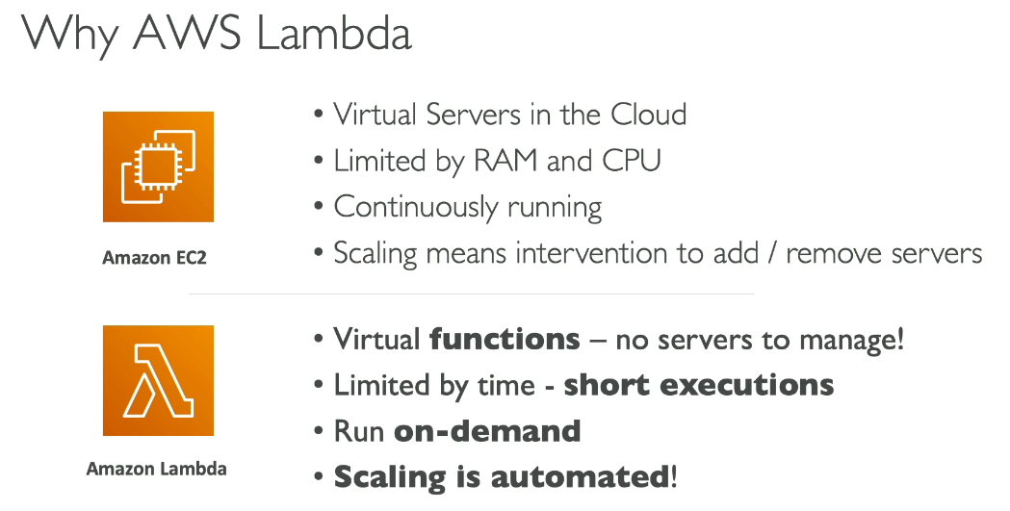

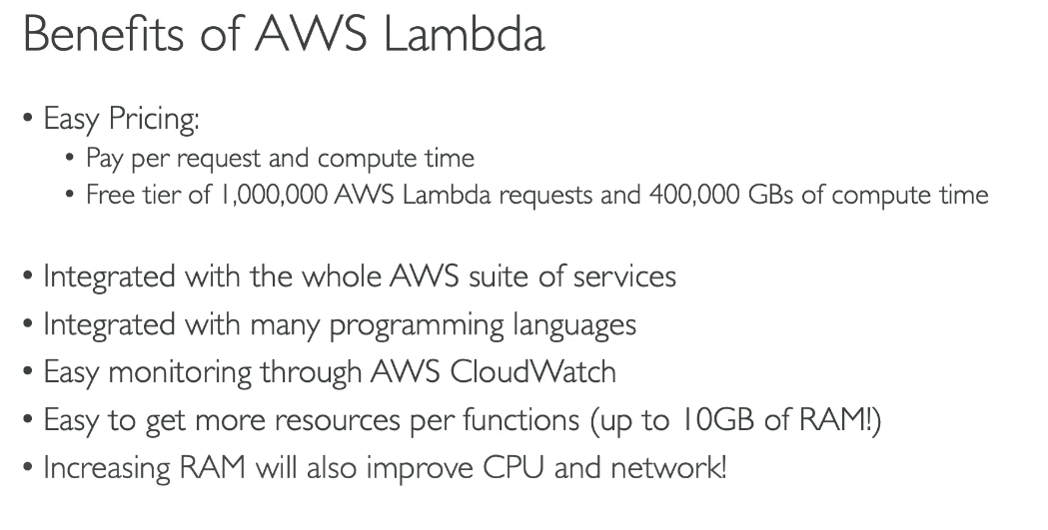

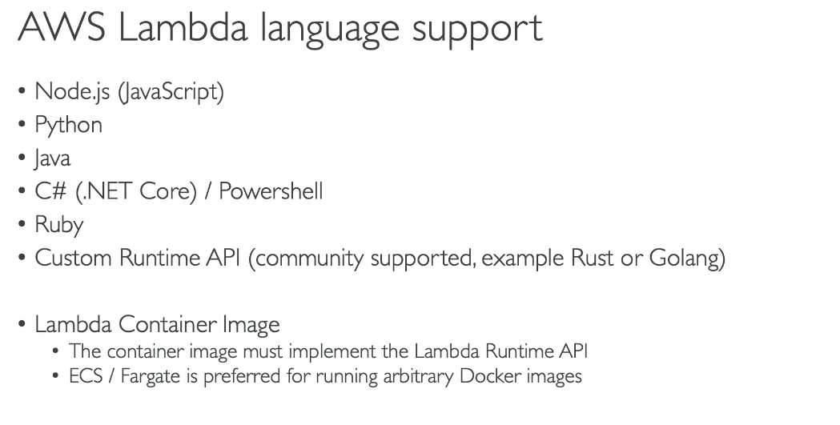

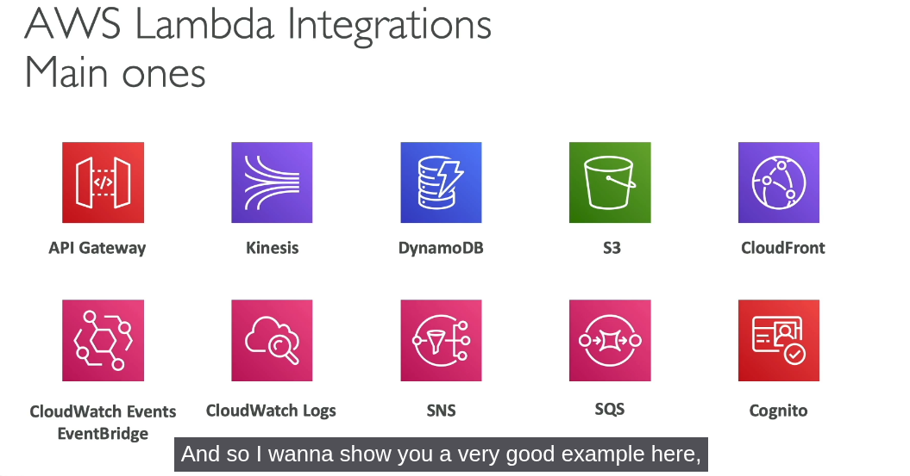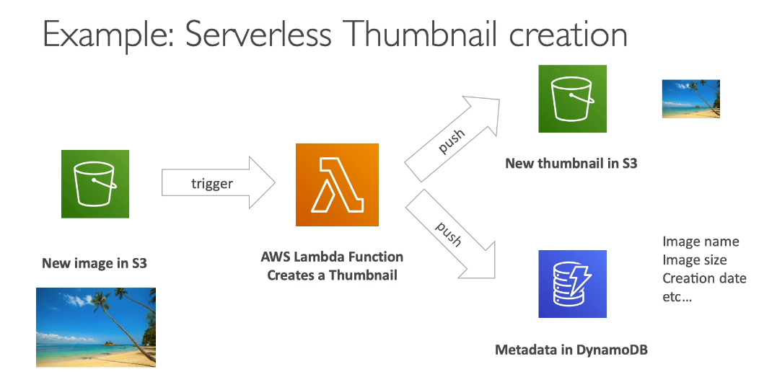

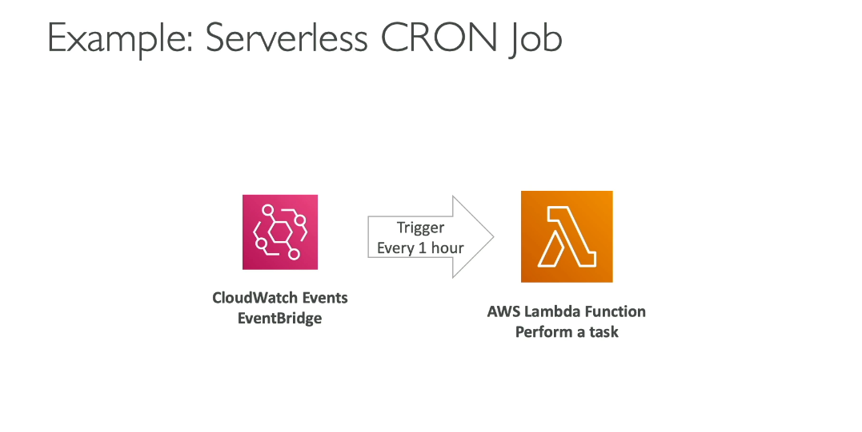

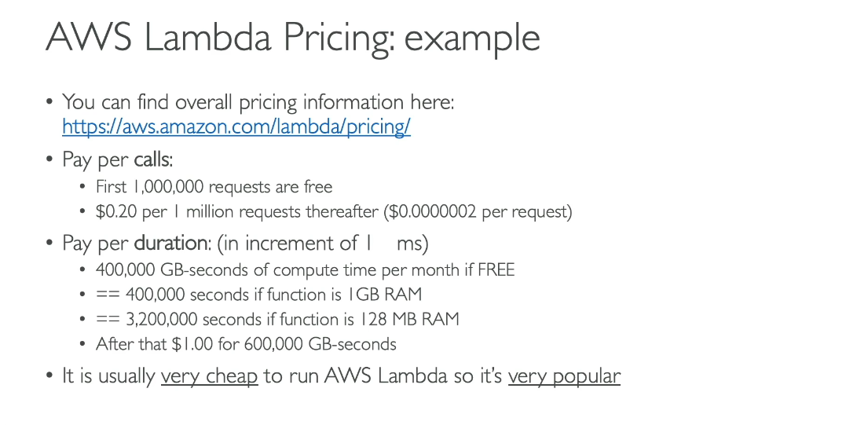

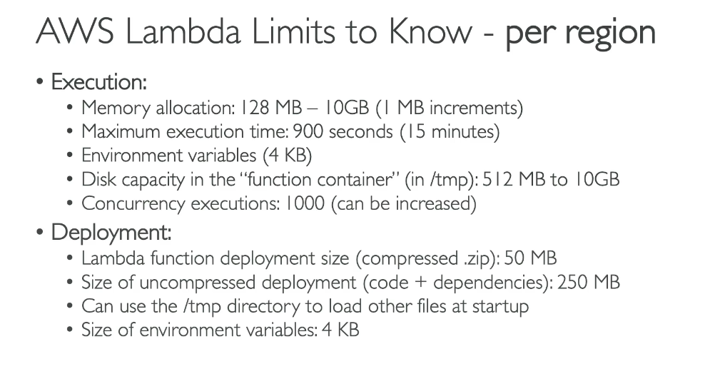“Concurrency executions” = how many **instances of your Lambda function can run at the same time** in a region.

Example to hammer it in:

* Your Lambda gets **1 request → 1 execution**
* 50 simultaneous requests → **50 concurrent executions**
* 2000 simultaneous requests → AWS tries to spin **2000 parallel copies** (if limit allows)

By default, AWS caps you at **1000 concurrent executions per region**. That’s **not per function**, that’s for your whole account in that region. If you have 5 Lambdas being hit at once, they all share that pool.

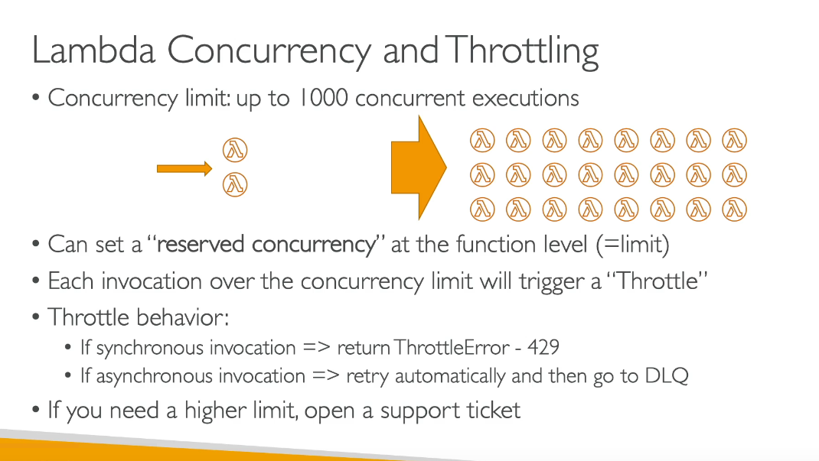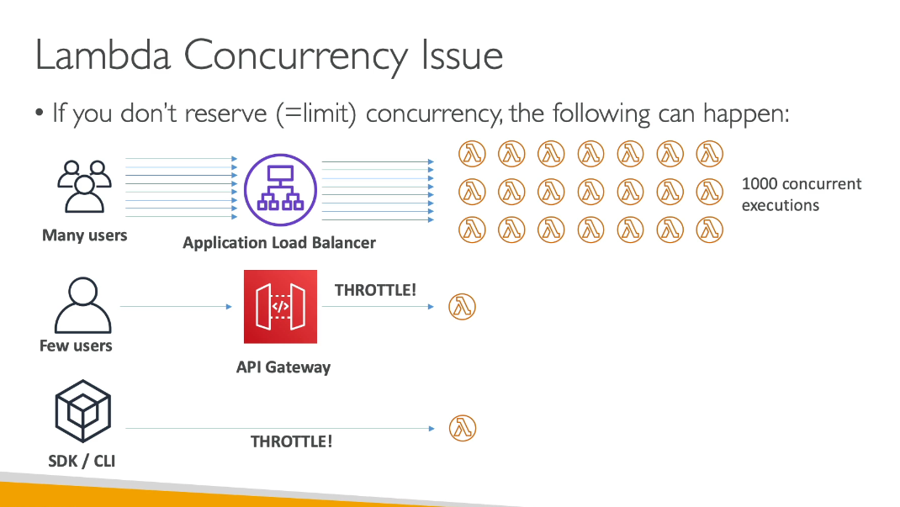

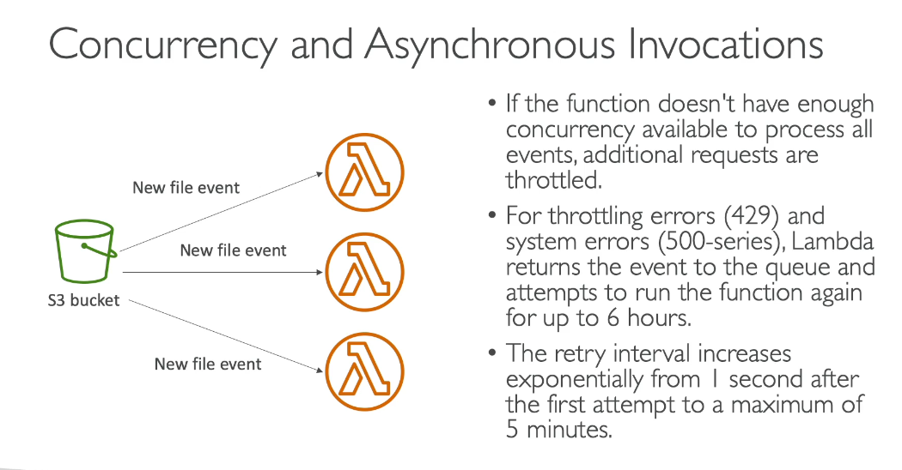

**429 – Throttling errors**

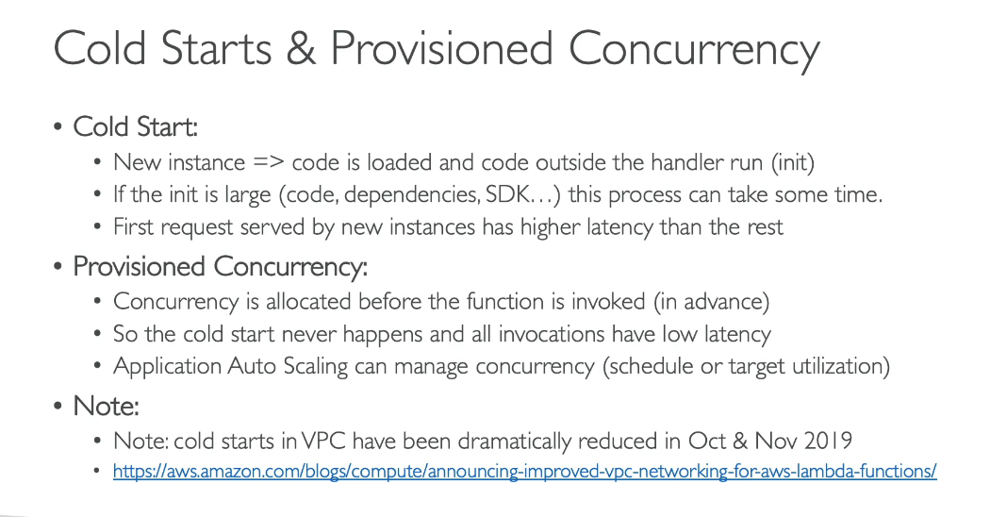

**Reserved Concurrency** =  
 ➡️ *A hard limit. Guarantees a max capacity for a function and prevents other functions from stealing it.*

**Provisioned Concurrency** =  
 ➡️ *Pre-warmed instances. Guarantees that X concurrent executions are already initialized → zero cold starts.*

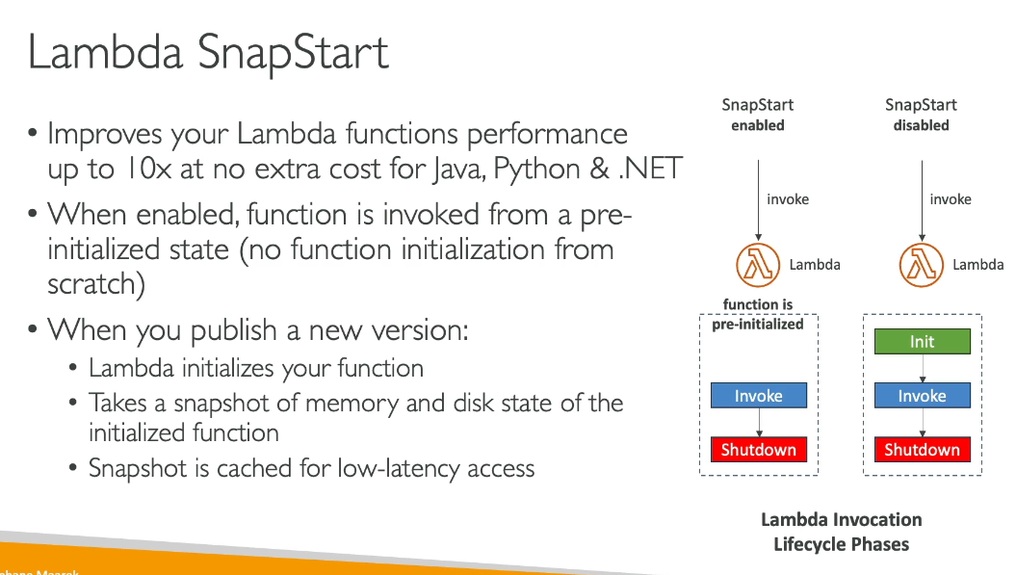

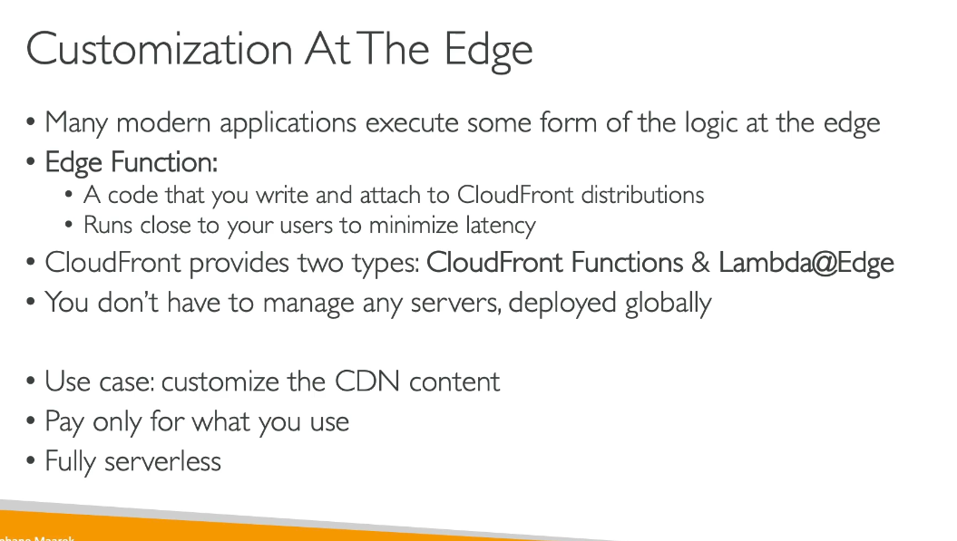

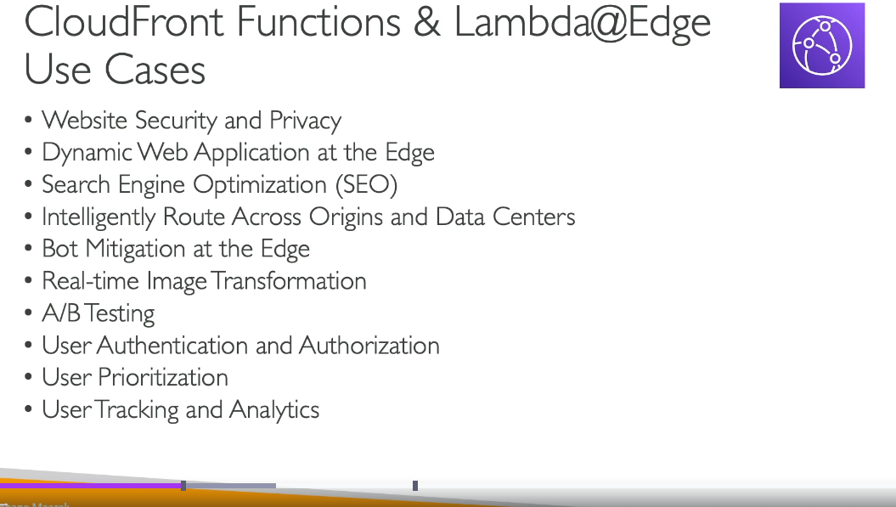

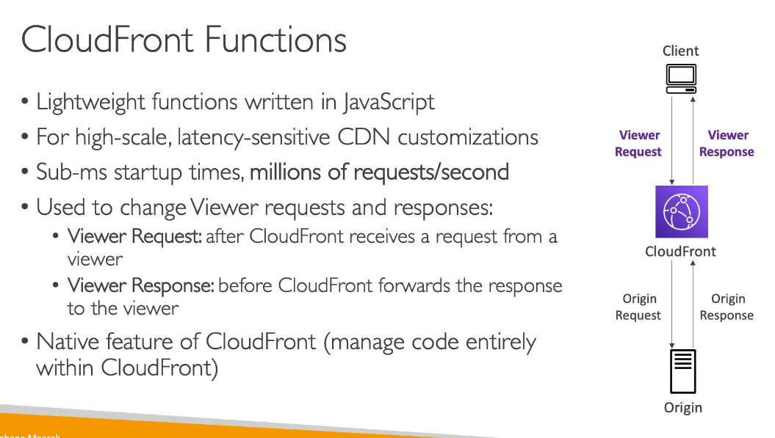

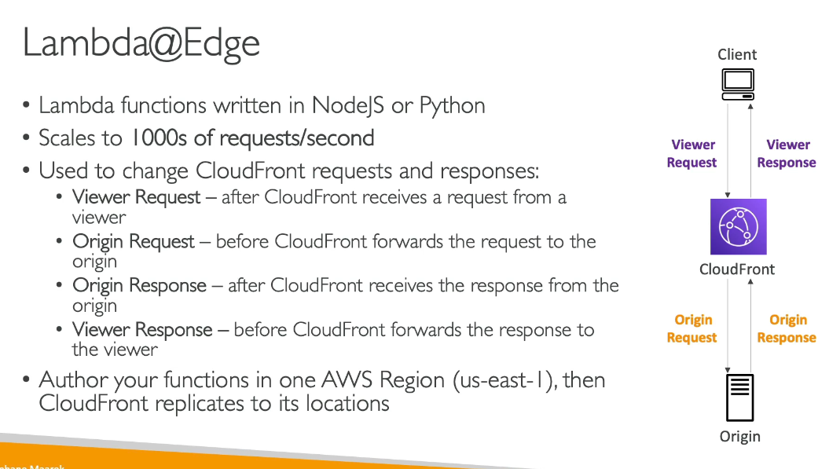

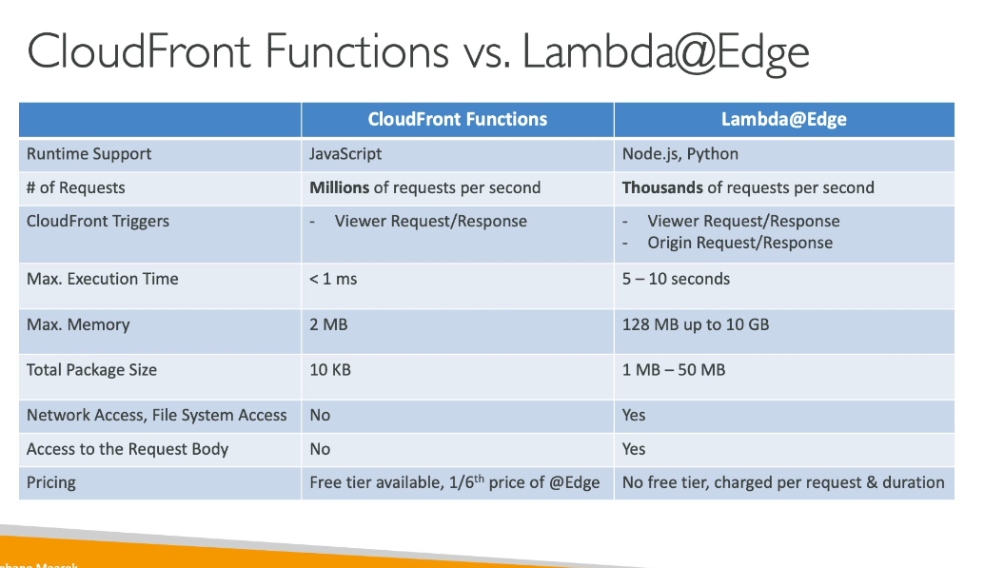

**CloudFront functions are used for more light weight/basic tasks like allow/block some IP’s but lambda@edge is used for more complex code and tasks like authentication and etc.. But both are running or executing at the edge locations only**

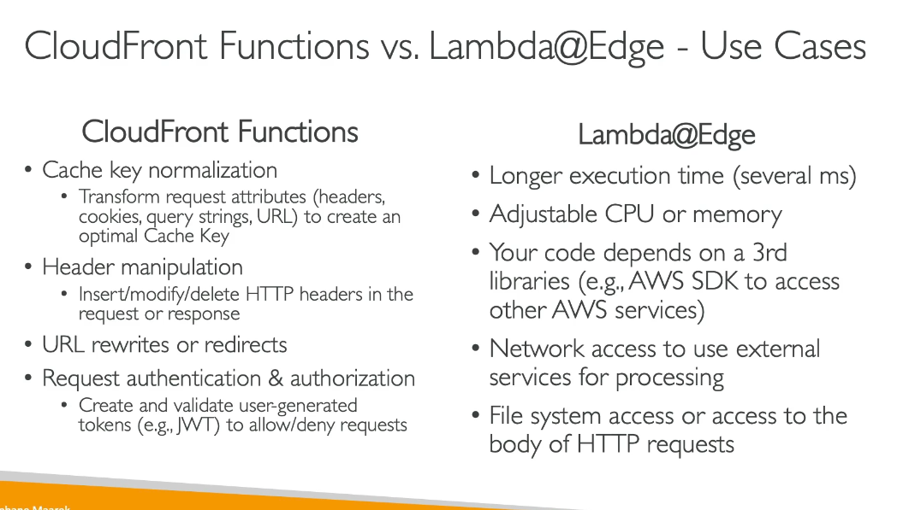

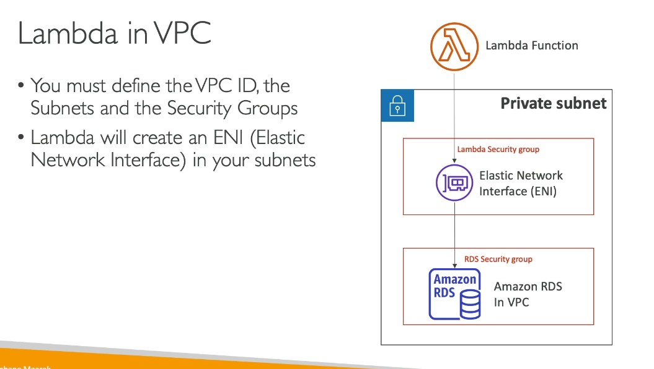

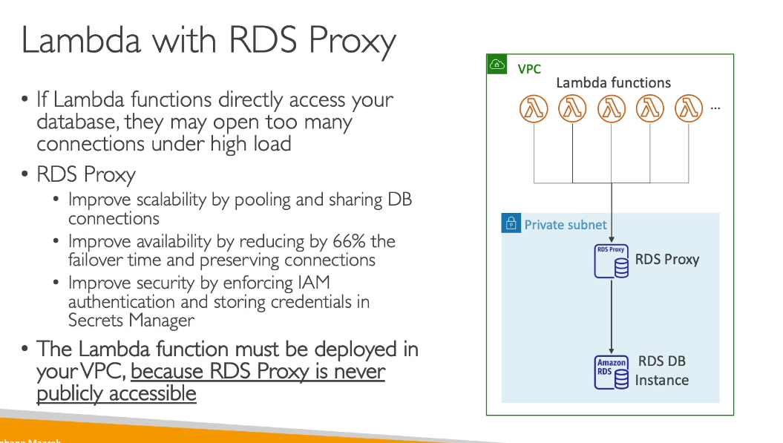

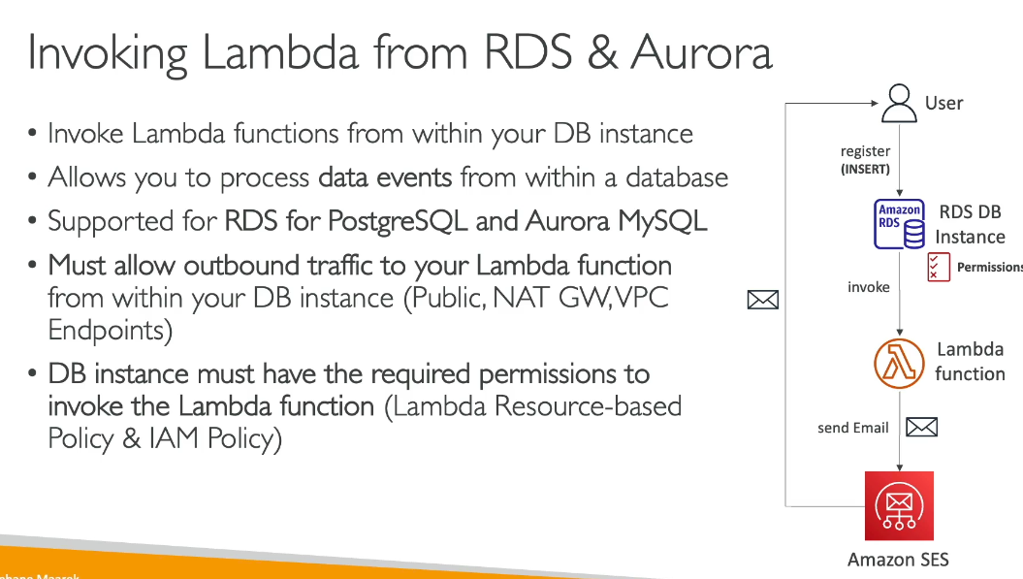

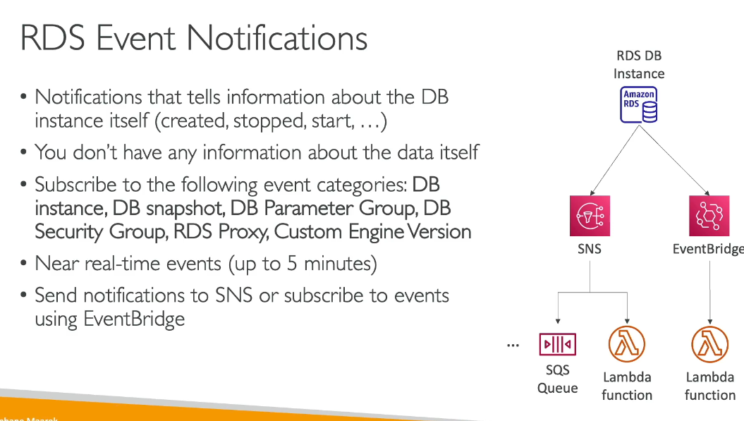

Dynamo DB

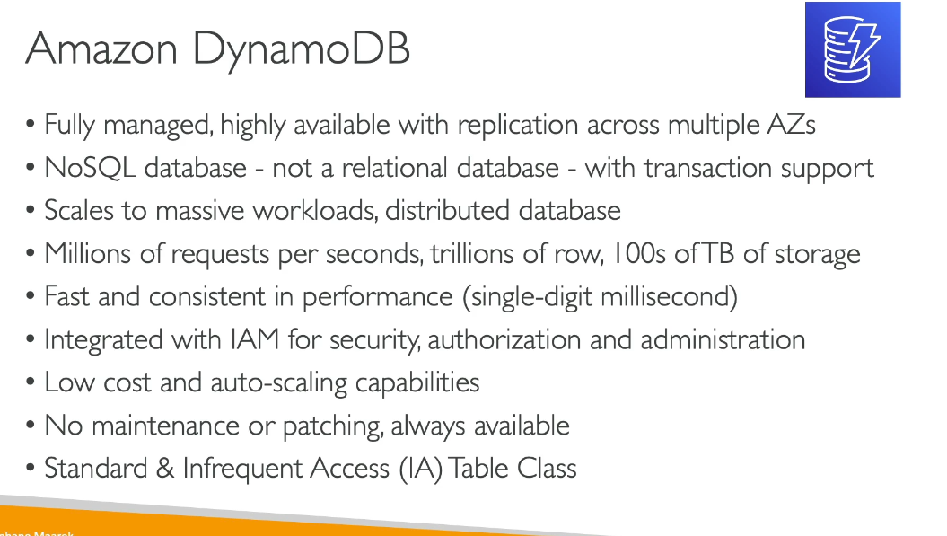

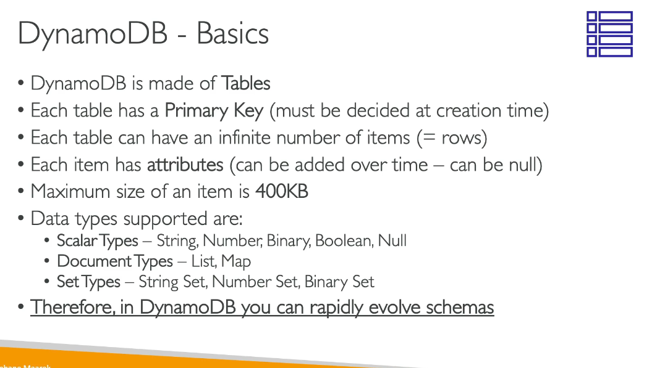

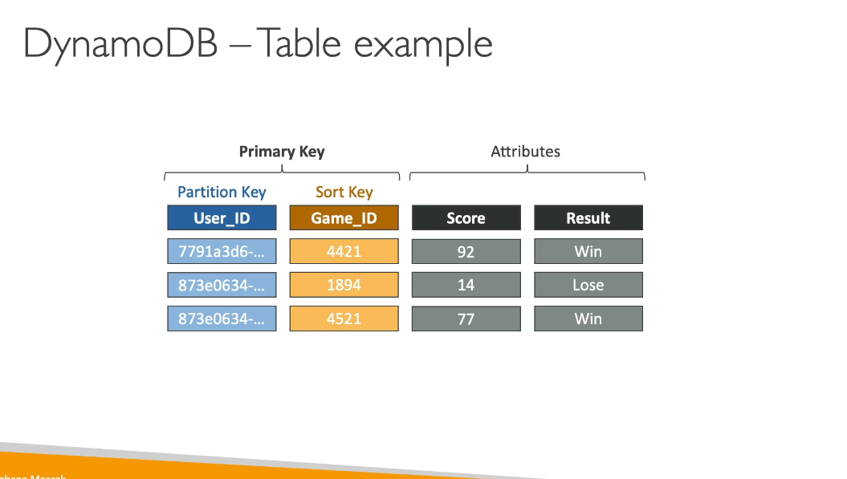

In Amazon DynamoDB, the primary key of a table can be composed of one or two attributes. These attributes are known as the partition key and the sort key. Let's break down each of these:

1. Partition Key:
   1. Also called a hash key
   2. It's the primary attribute used to identify an item in a DynamoDB table
   3. DynamoDB uses the partition key value as input to an internal hash function
   4. The output of this hash function determines the partition (physical storage location) where the item will be stored
   5. In tables with only a partition key, each item must have a unique partition key value
2. Sort Key:
   1. Also called a range key
   2. It's an optional second part of a table's primary key
   3. Used in combination with the partition key to create a composite primary key
   4. Allows for multiple items to have the same partition key value, as long as they have different sort key values
   5. Items with the same partition key are stored together, in sorted order by the sort key value

When a table has both a partition key and a sort key (composite primary key):

* Multiple items can share the same partition key value
* These items must have different sort key values
* DynamoDB keeps items with the same partition key value close together, sorted by the sort key value
* This arrangement is called an item collection

The combination of partition key and sort key offers several benefits:

1. It allows for more flexible and efficient querying of data
2. You can retrieve all items with a specific partition key, or a subset of those items by specifying a range of sort key values
3. It enables modeling of one-to-many relationships in your data

For example, in a Music table with Artist (partition key) and SongTitle (sort key):

* You can efficiently retrieve all songs by a particular artist
* You can also retrieve a subset of songs by an artist by providing a range of SongTitle values

When querying data:

* You must always provide the partition key value
* The sort key is optional, but can be used to refine your query

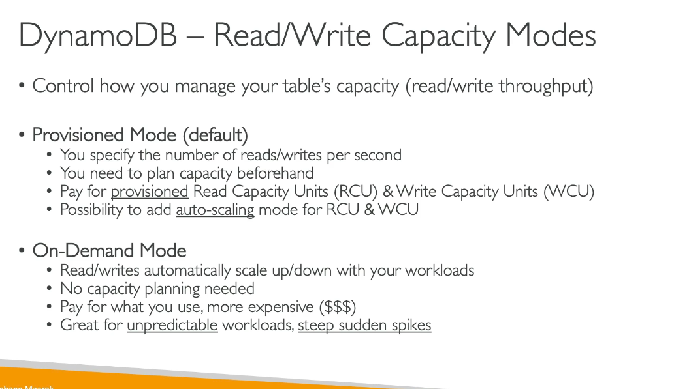

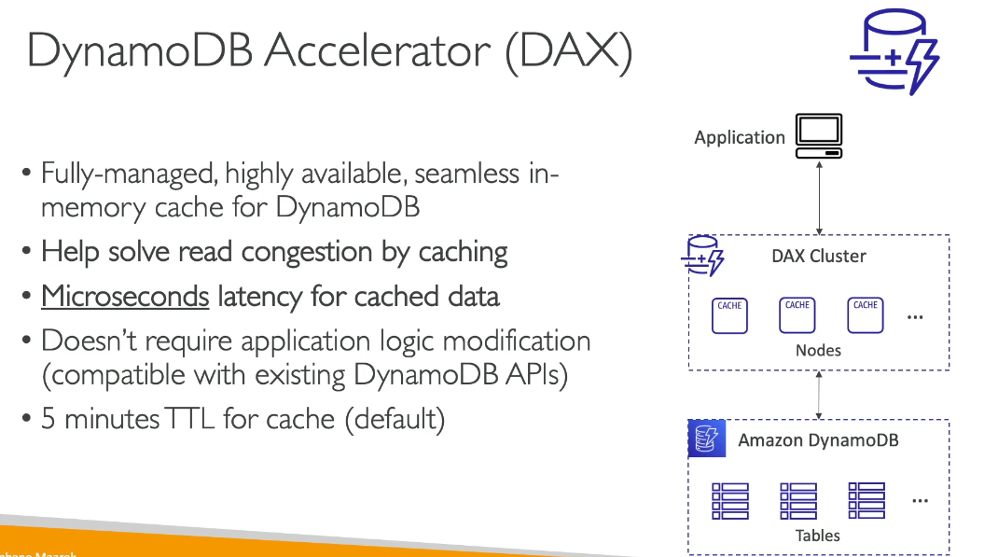

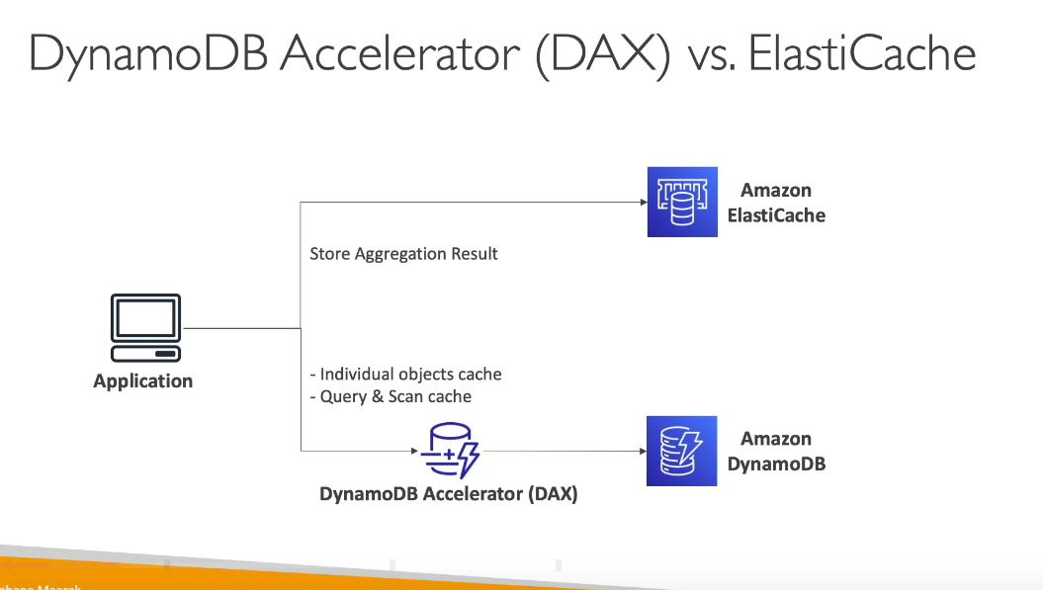

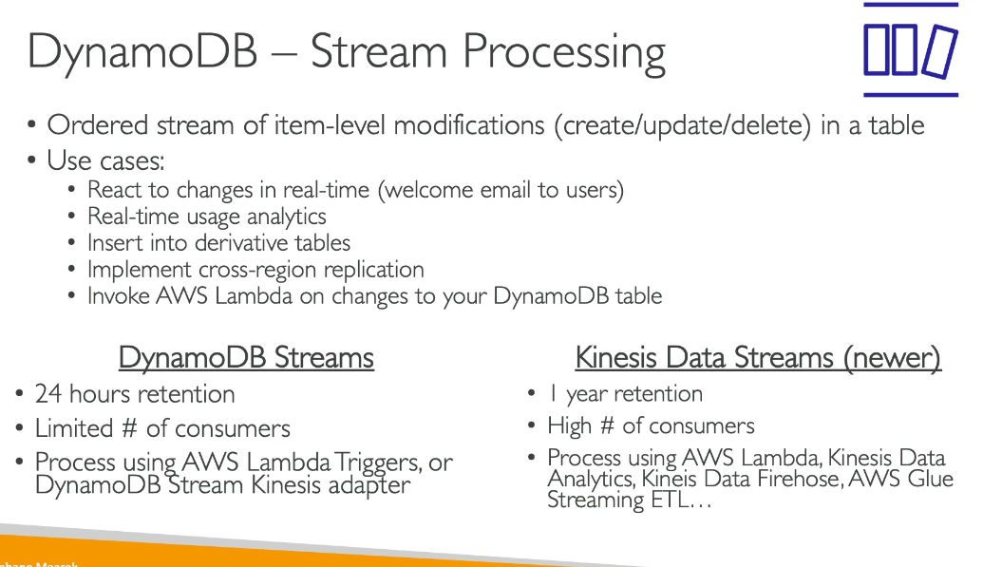

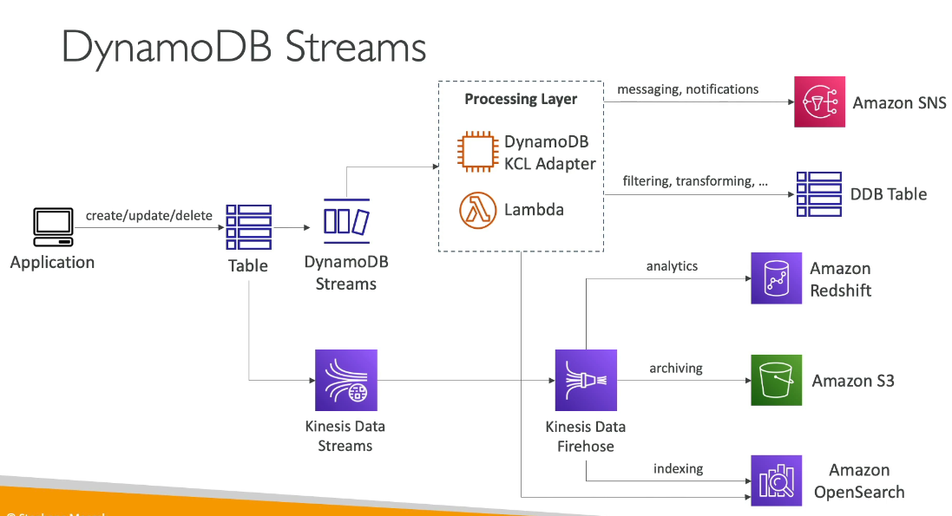

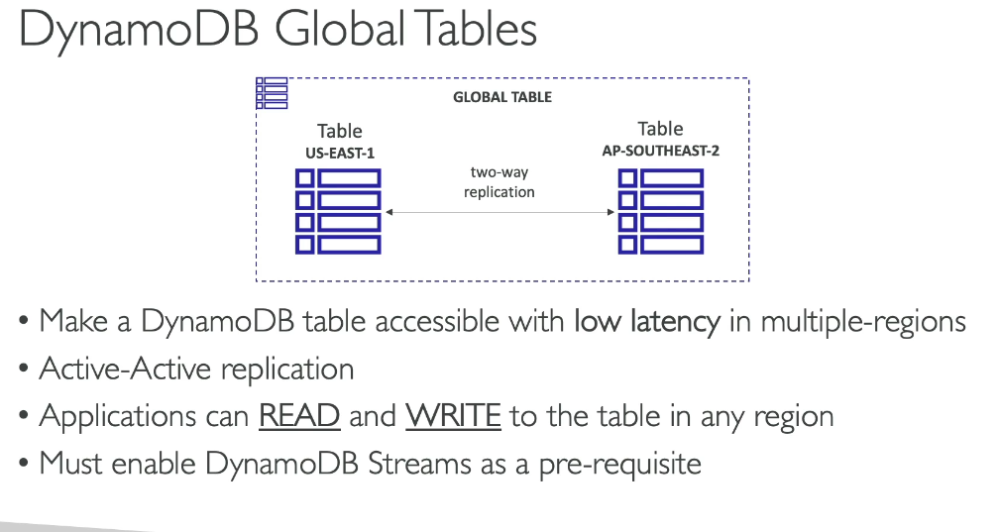

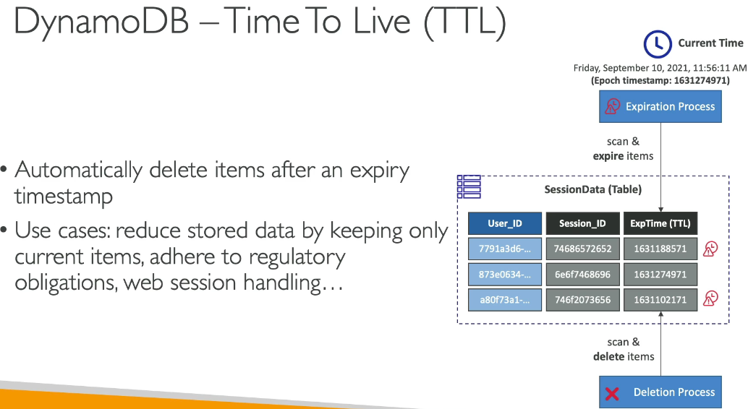

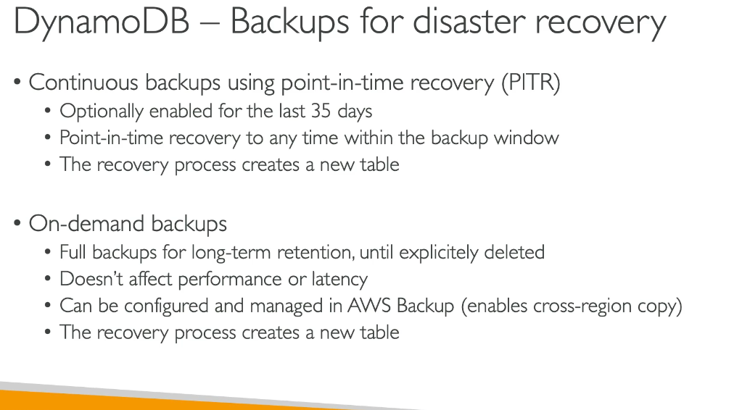

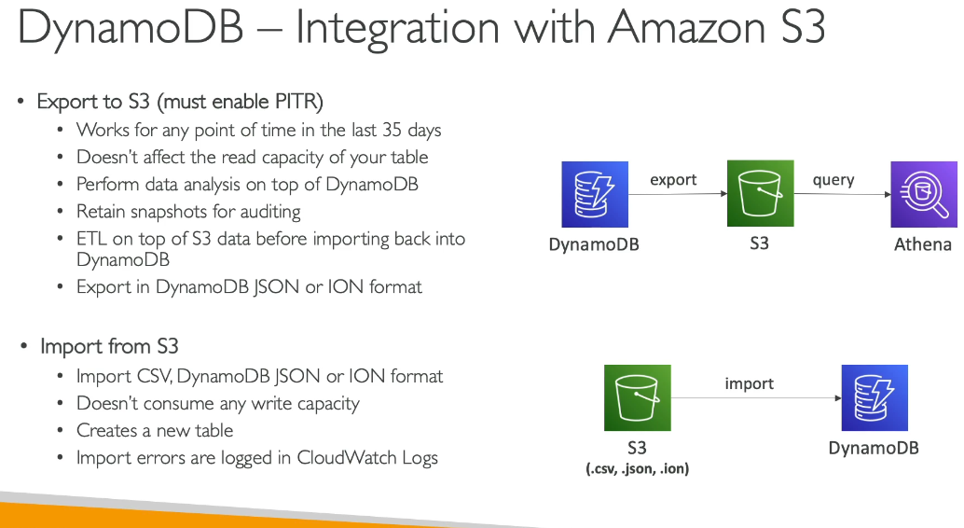

API Gateway:

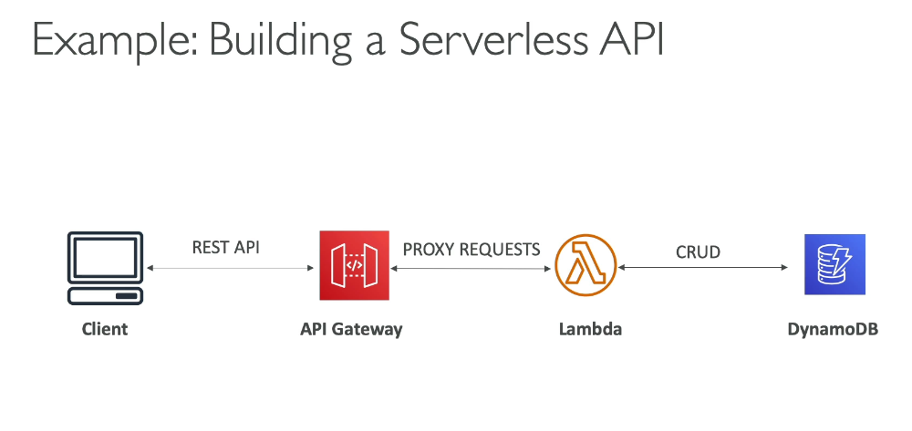

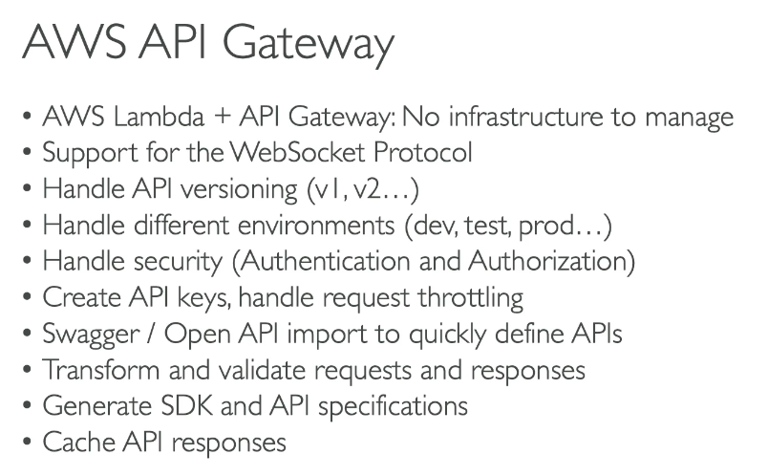

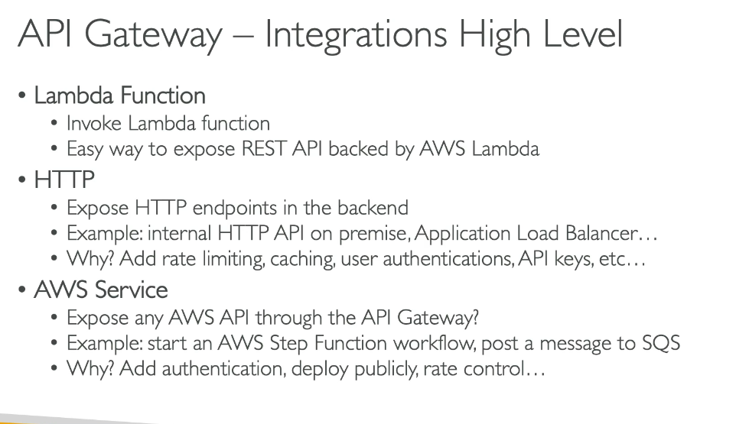

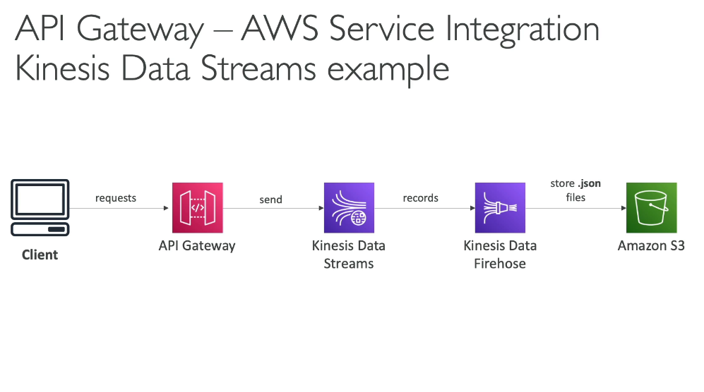

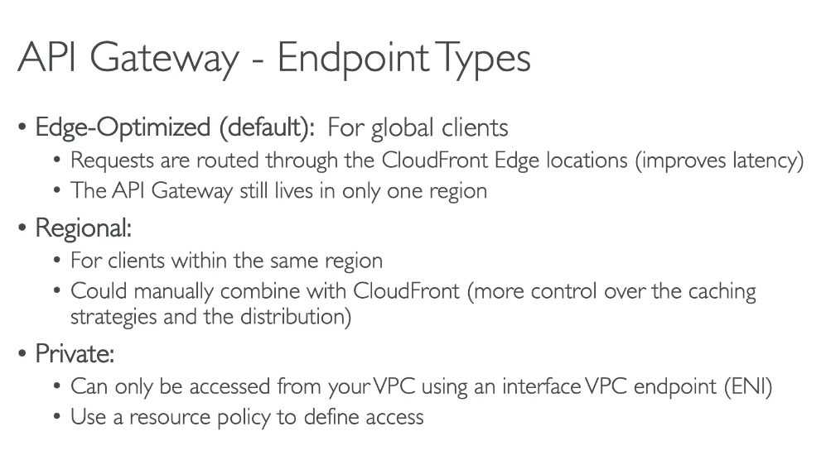

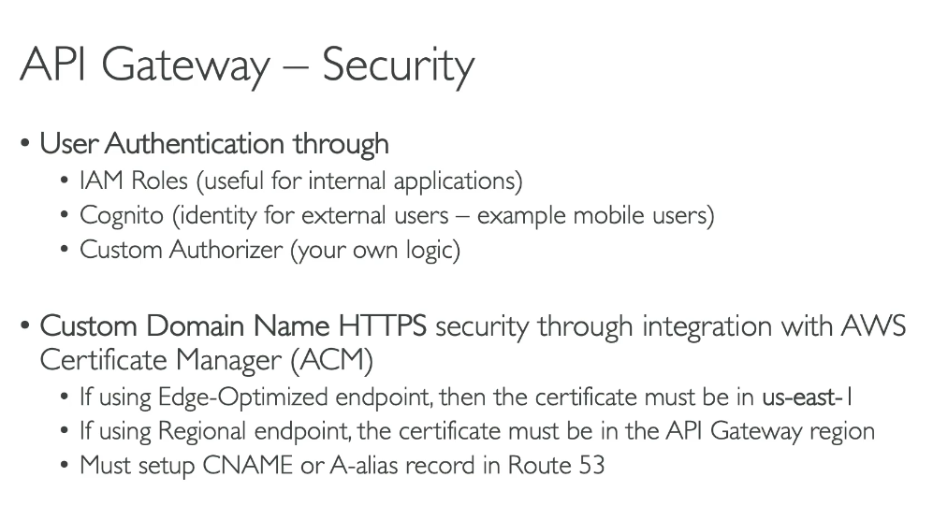

Step Functions:

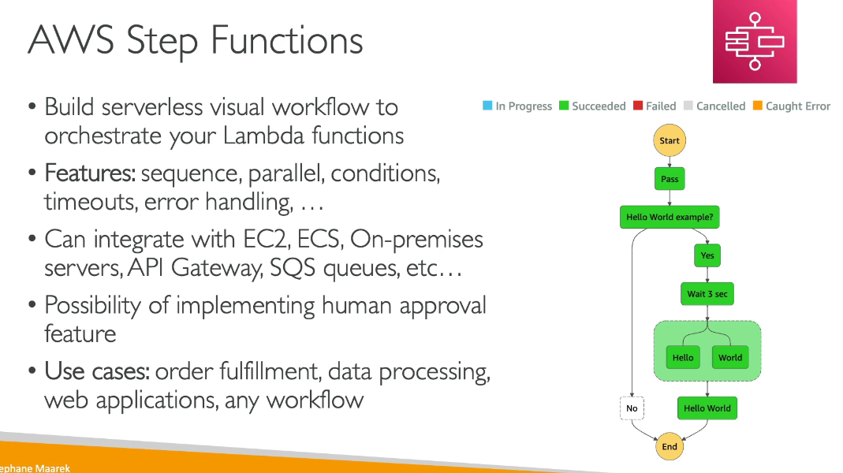

**AWS Cognito:**

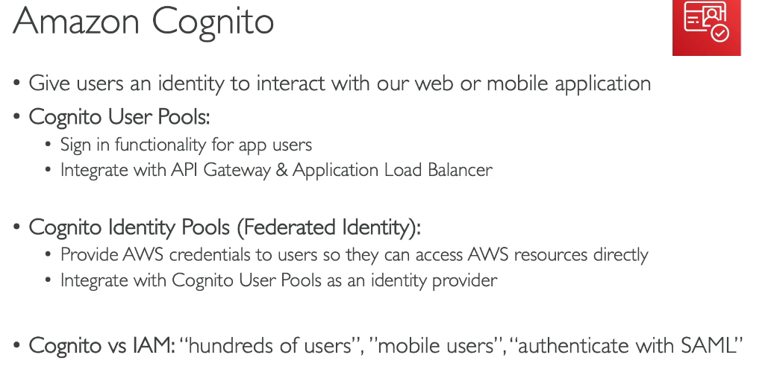

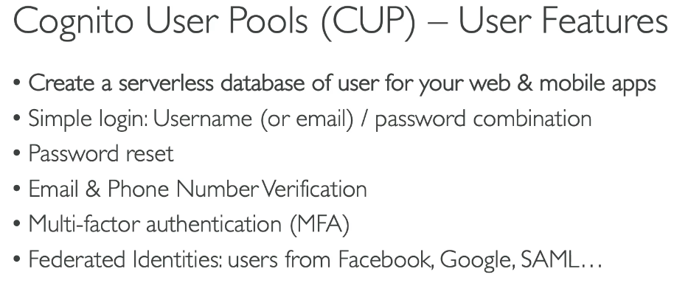

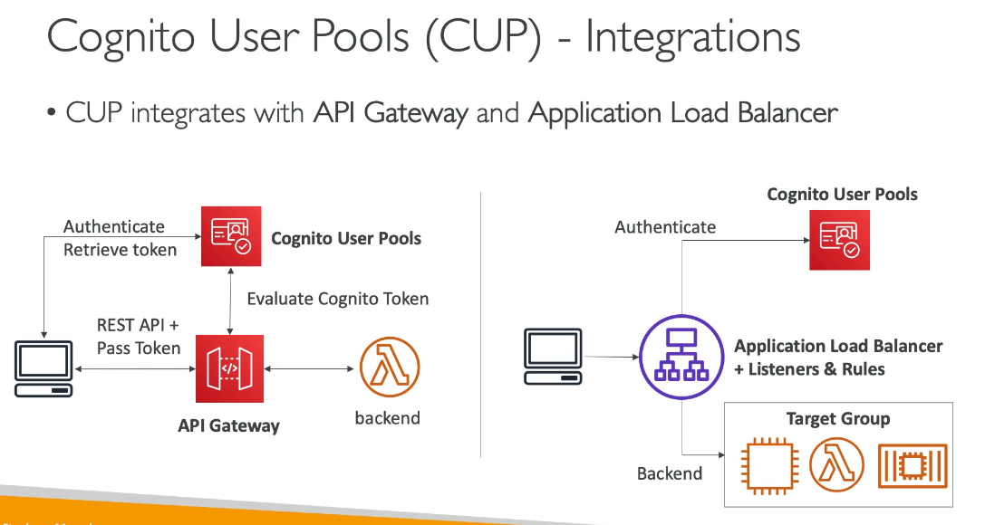

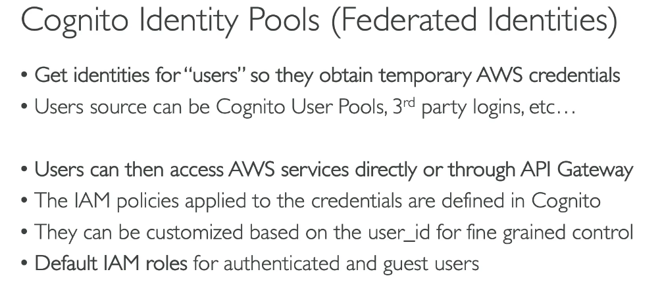

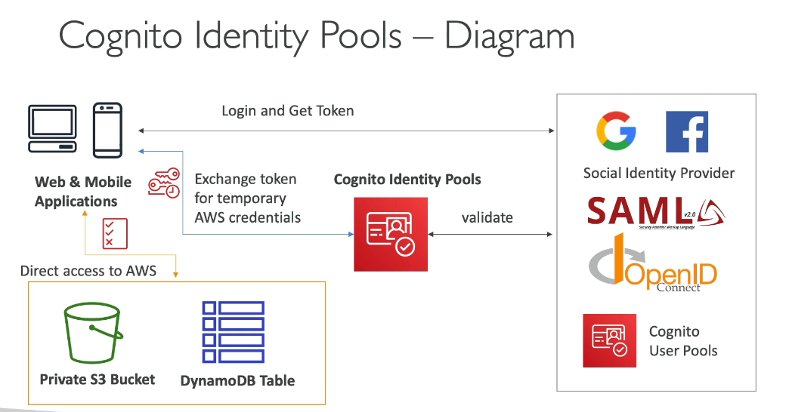

**Architectures:**

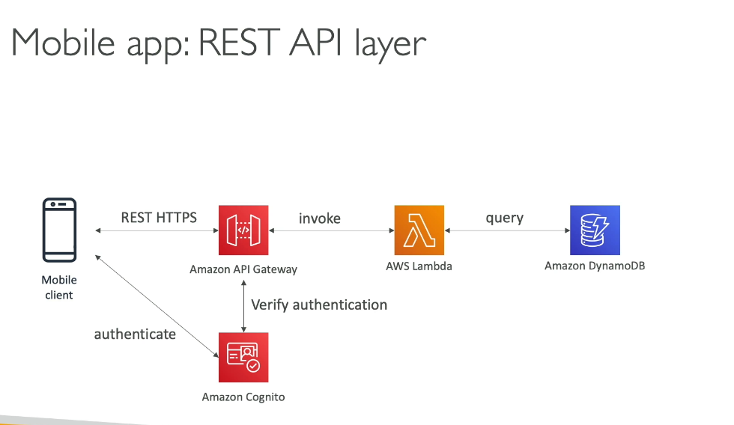

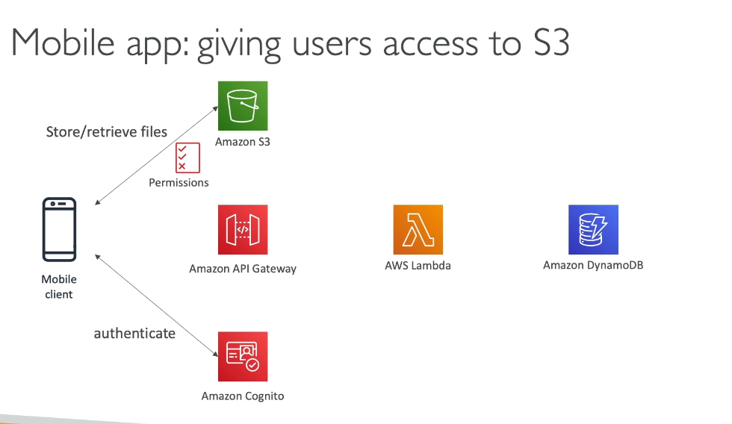

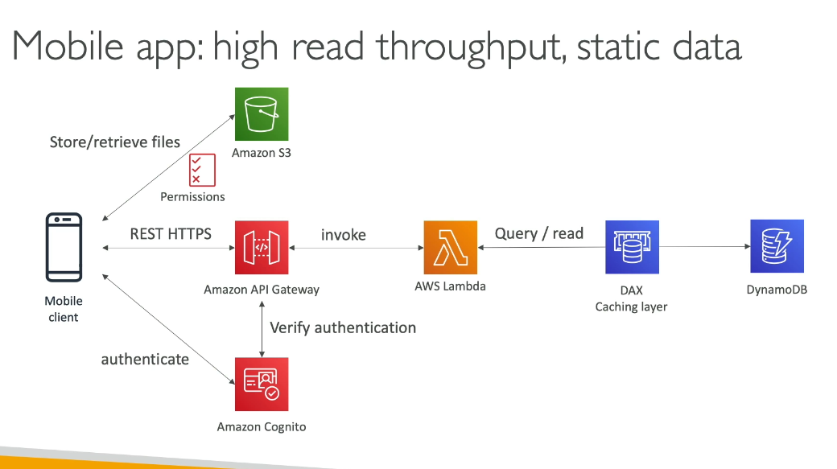

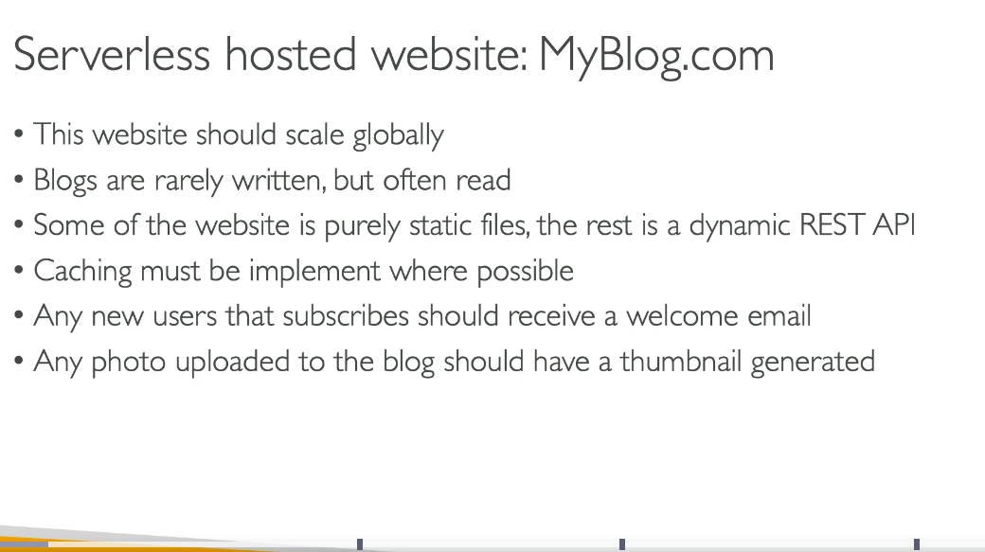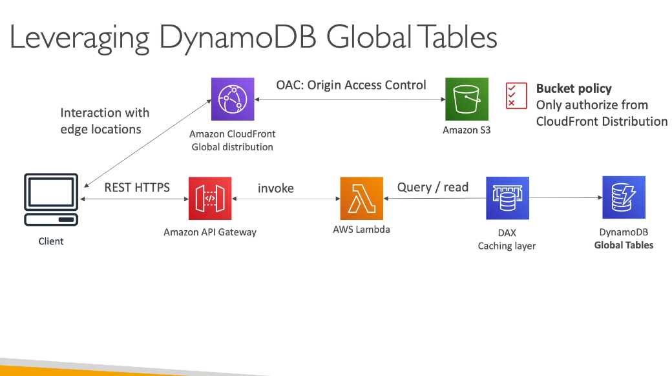

**OAC** stands for Origin Access Control, which is a feature of Amazon CloudFront that helps you secure access to your origins, particularly Amazon S3 buckets.

Key features of OAC include:

* Enhanced security: Restricts direct access to your S3 bucket, ensuring content is only accessible through CloudFront
* AWS Signature Version 4 (SigV4) support: Provides stronger authentication compared to the legacy Origin Access Identity (OAI)
* Support for additional features: Works with S3 features like server-side encryption with AWS KMS (SSE-KMS), dynamic requests (PUT/POST/DELETE), and S3 Object Lambda

OAC is the recommended approach for securing S3 origins with CloudFront, replacing the older Origin Access Identity (OAI) feature.

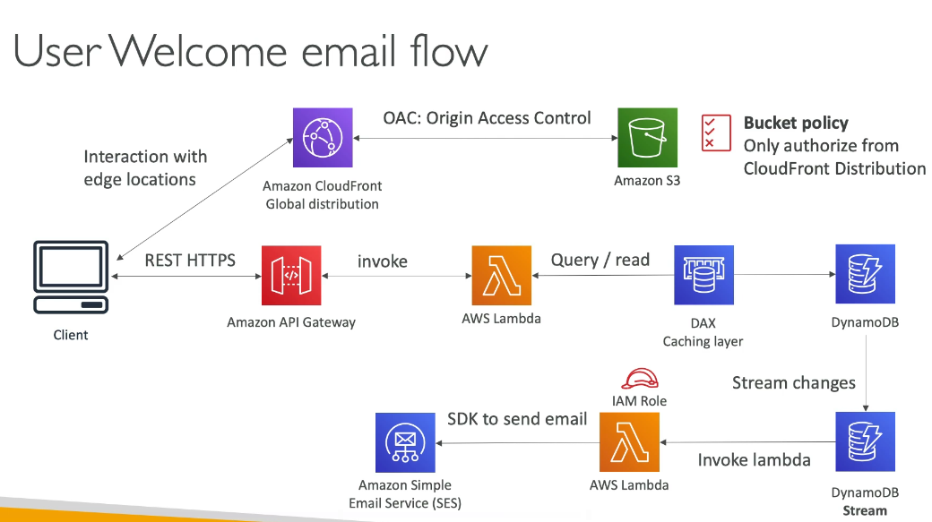

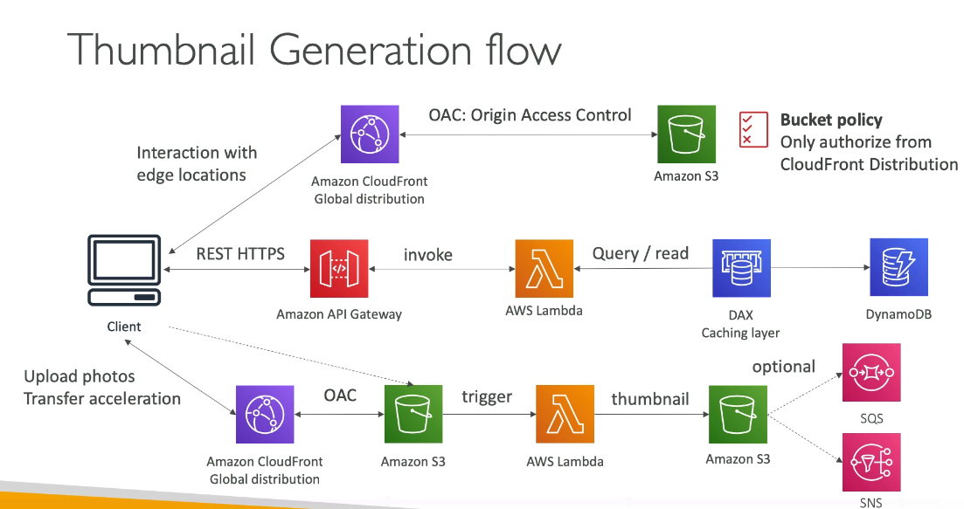

Amazon S3 **Transfer Acceleration** is a bucket-level feature that enables fast, easy, and secure transfers of files over long distances between your client and an S3 bucket.

How it works:

* Routes traffic through Amazon CloudFront's globally distributed edge locations
* Data arriving at an edge location is then routed to S3 over an optimized network path
* Uses network protocol optimizations to improve performance

Key benefits:

* Can speed up transfers by 50-500% for long-distance transfers of larger objects
* Reduces variability in Internet routing, congestion, and speeds
* Particularly useful when uploading from locations far from your S3 bucket

When to use it:

* Customers upload to a centralized bucket from all over the world
* Transferring gigabytes to terabytes of data across continents regularly
* Applications hosted far away from their S3 bucket

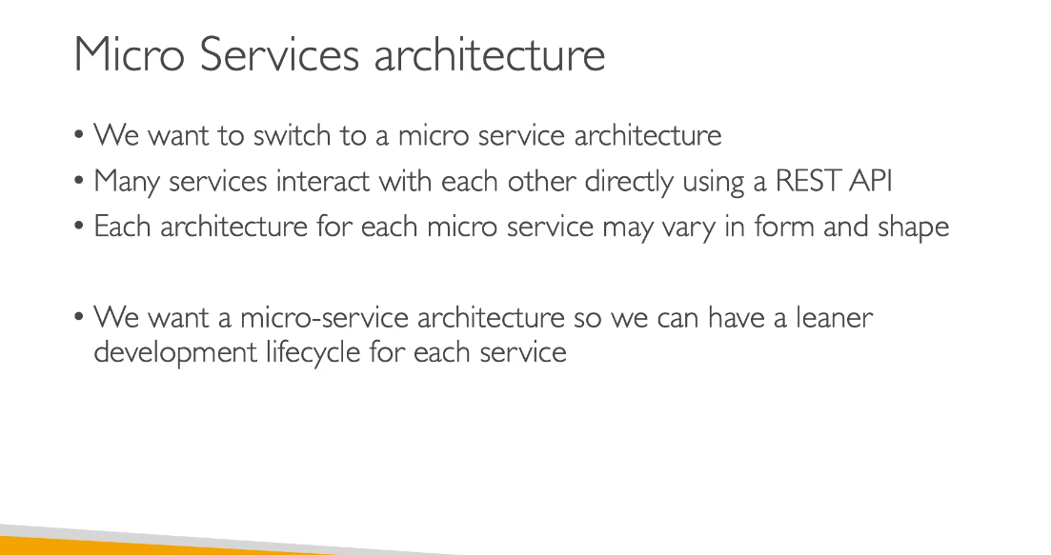

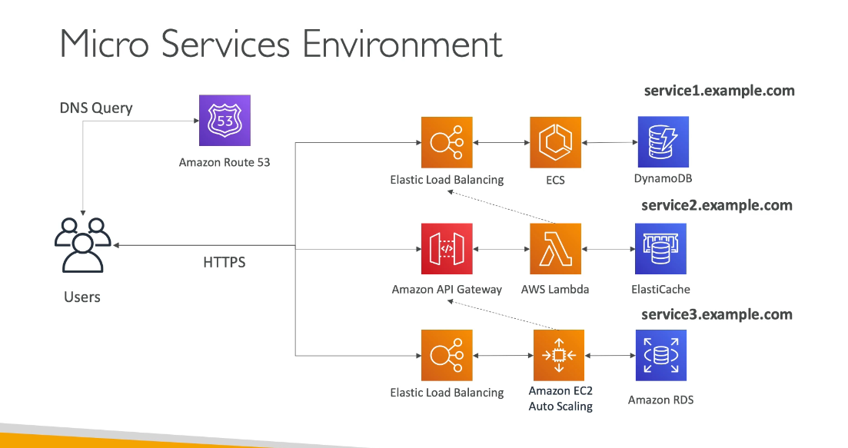

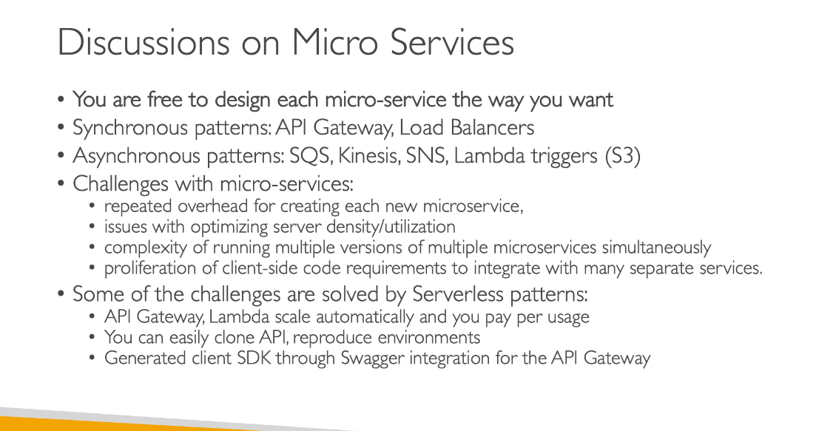

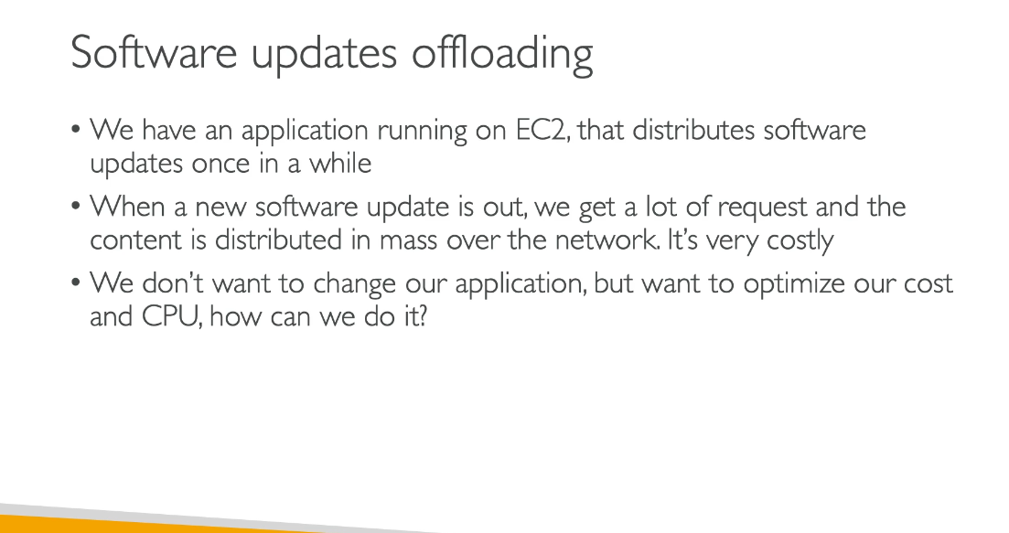

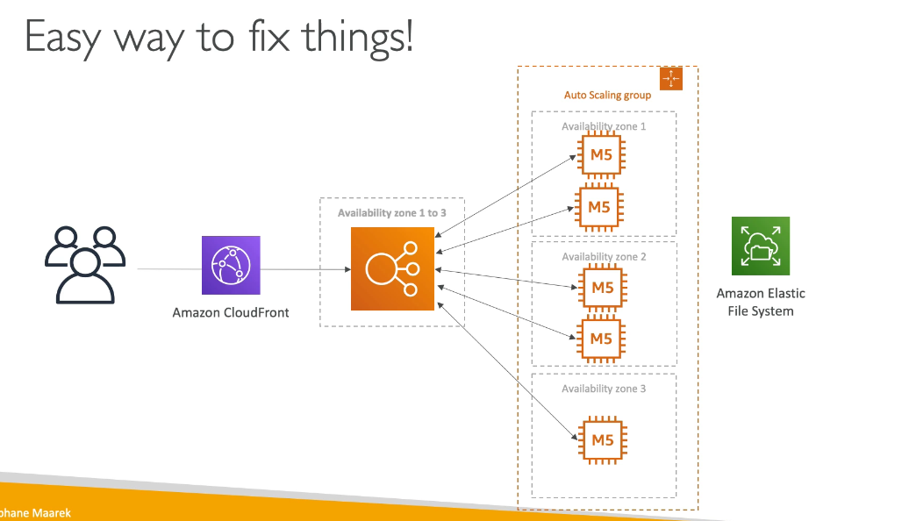

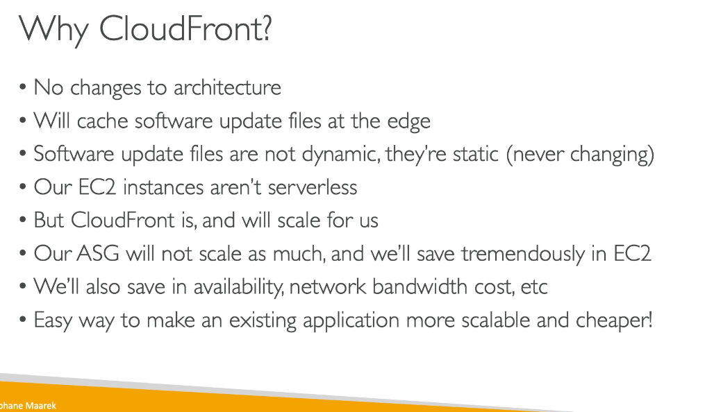

Quiz:

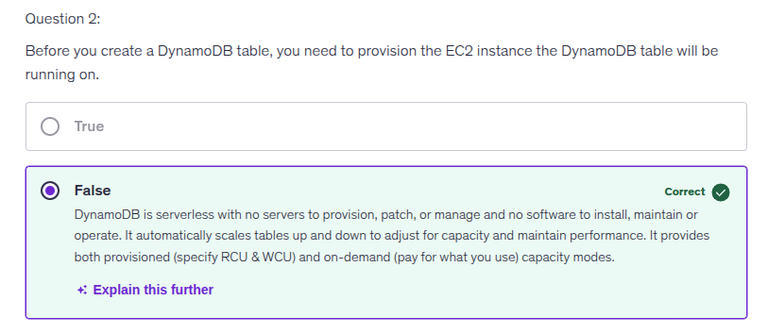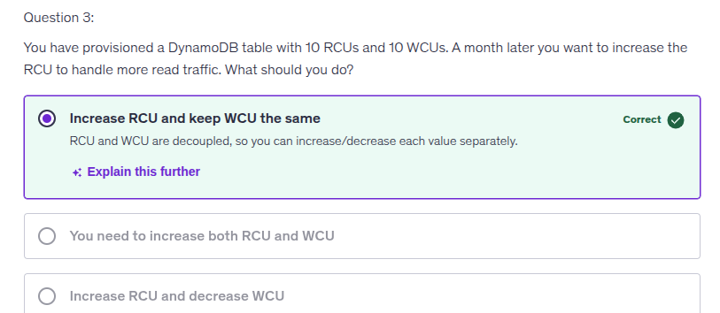

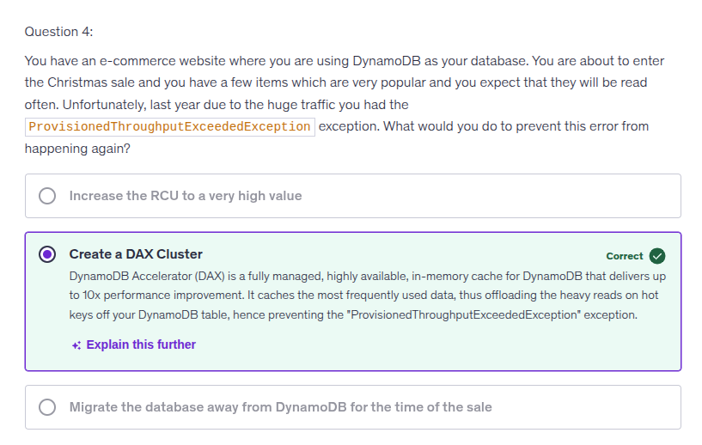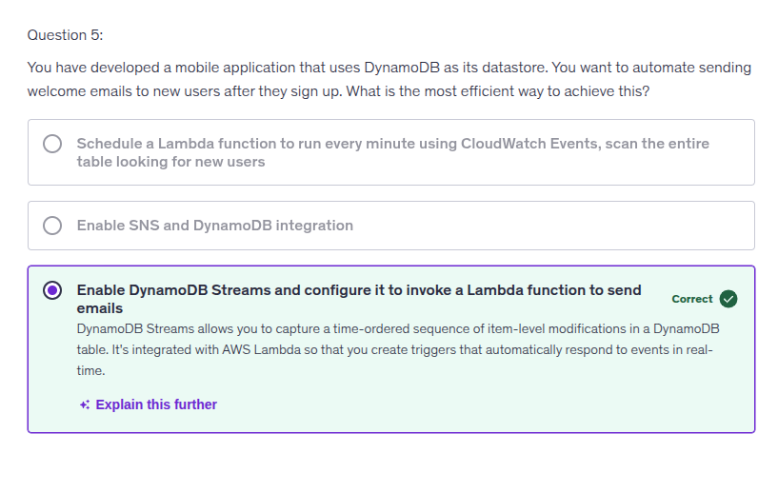

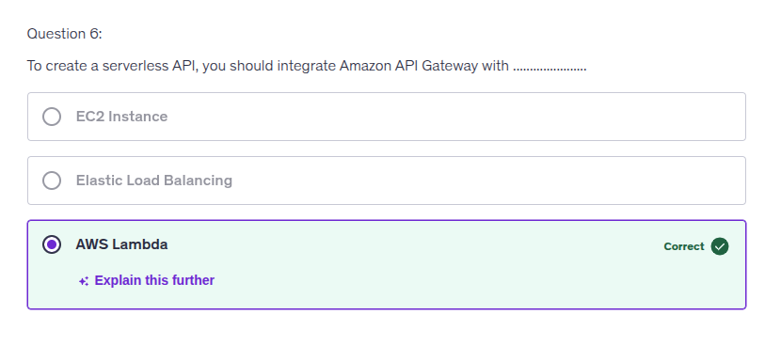

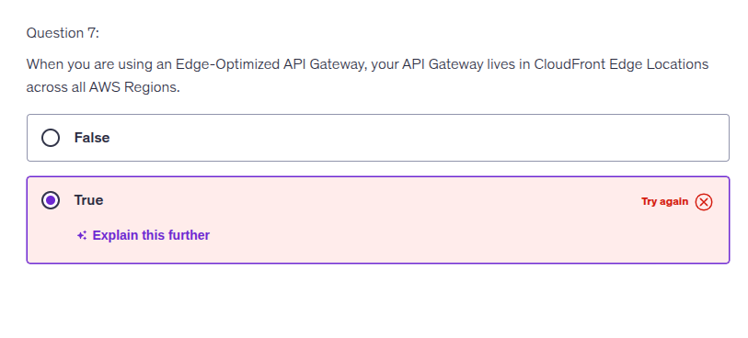

Choosing "True" implies that the API Gateway resides in multiple CloudFront Edge Locations across all AWS Regions. However, while an Edge-Optimized API Gateway does utilize CloudFront to route requests from geographically distributed clients to the nearest Edge Location, the API Gateway itself is hosted in a single AWS Region. It's important to understand that the Edge Locations facilitate improved performance by reducing latency, but they do not host the API Gateway itself. This distinction is crucial for grasping how Edge-Optimized API Gateways function within AWS architecture. Keep exploring these concepts to strengthen your understanding!

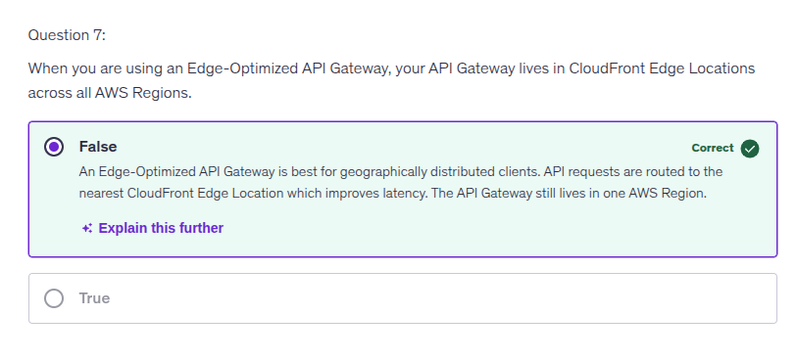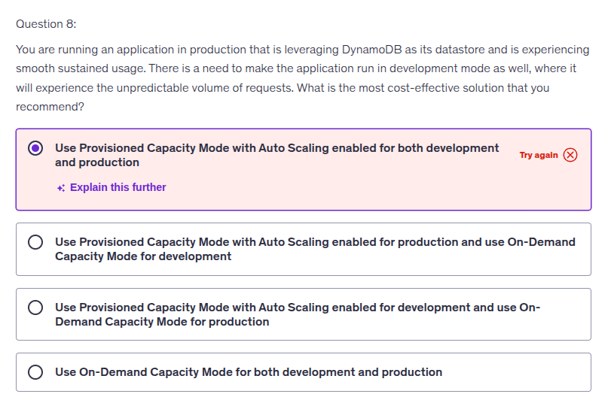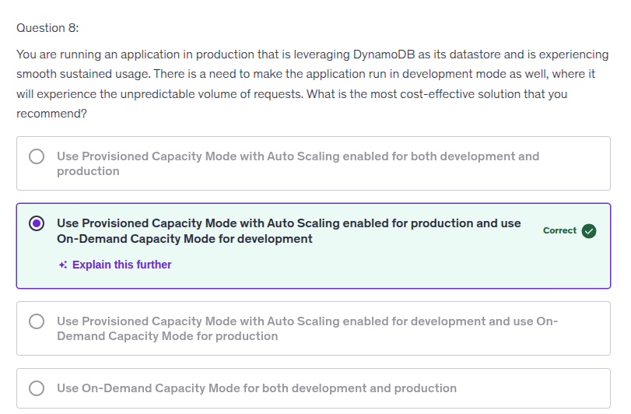

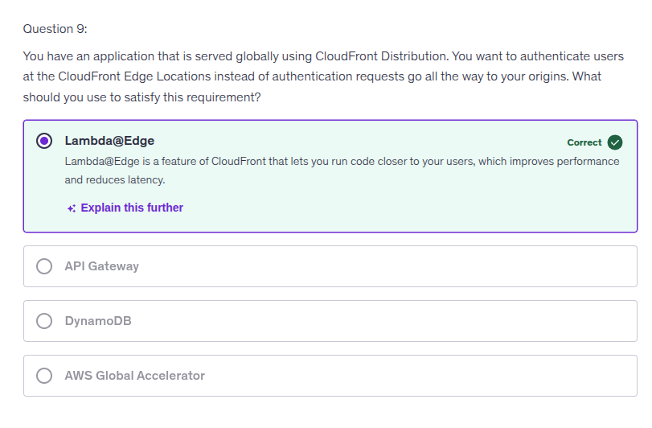

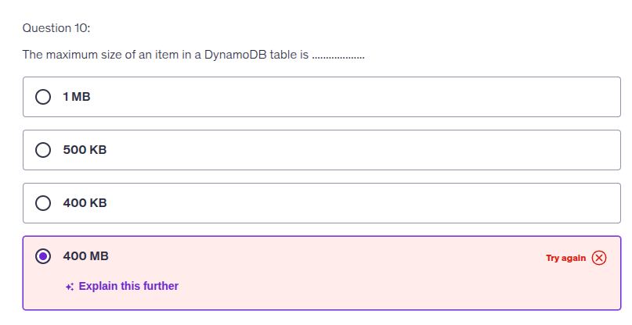

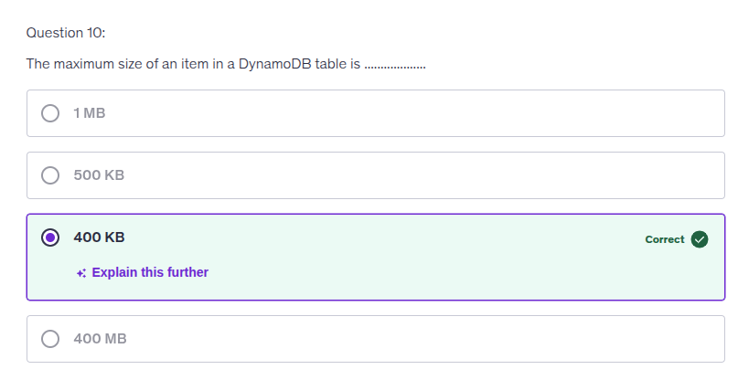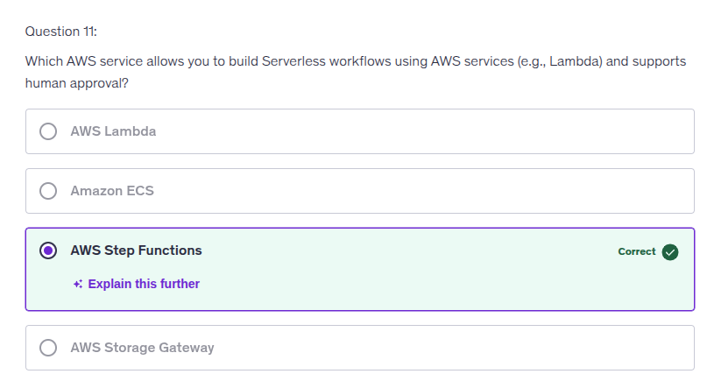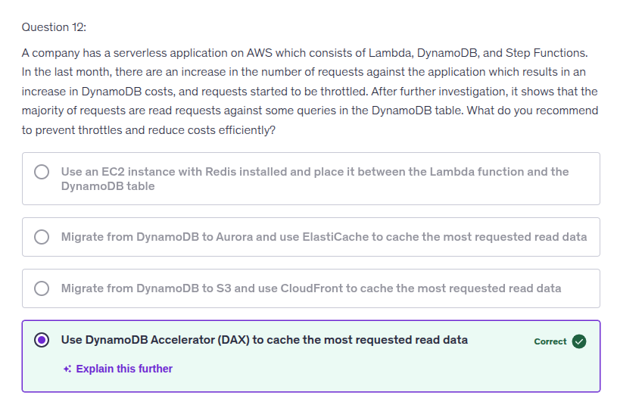

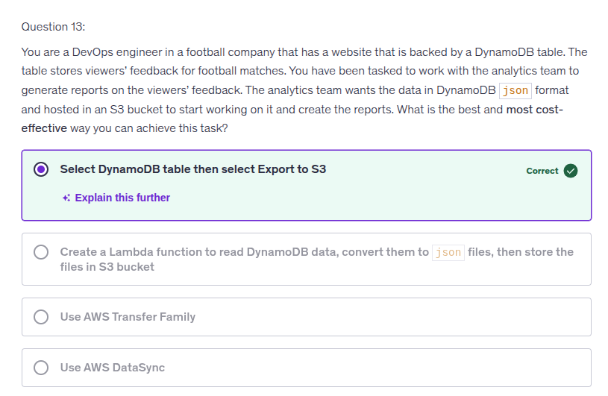Your choice of "Select DynamoDB table then select Export to S3" is correct because this option directly leverages the built-in functionality of DynamoDB, providing a cost-effective and efficient way to export data in JSON format to an S3 bucket, meeting the analytics team's requirements seamlessly. This method minimizes complexity while ensuring you maintain the required data format and accessibility for analysis.

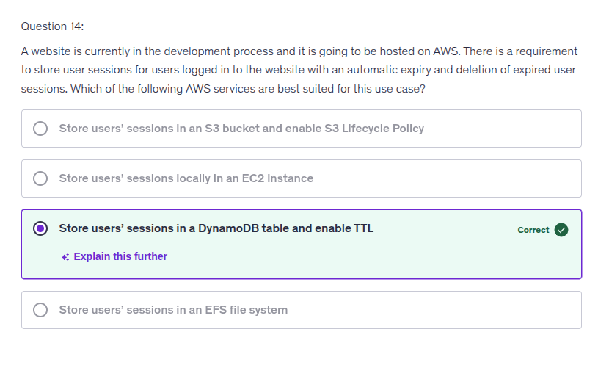

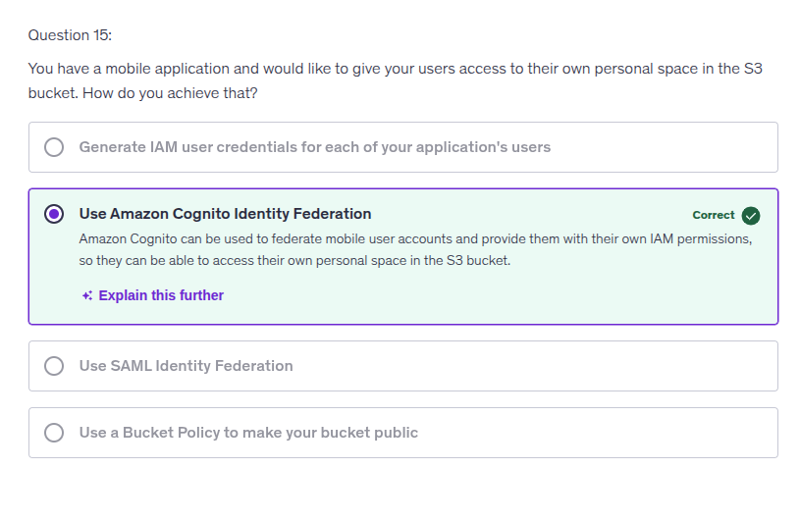

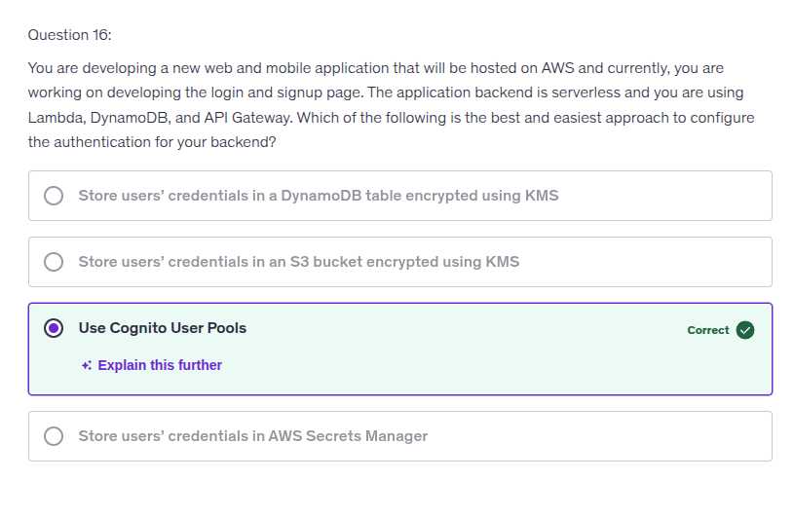

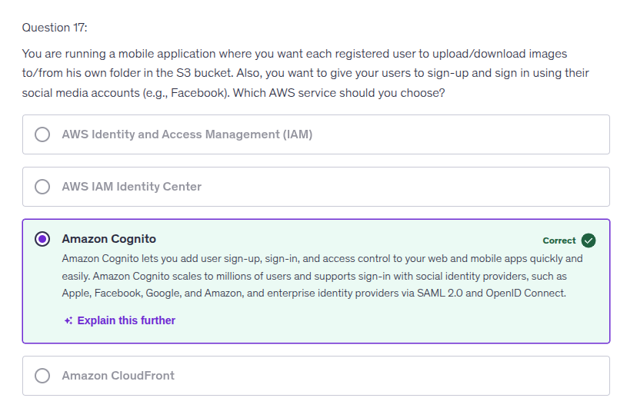

**Quiz 2:**

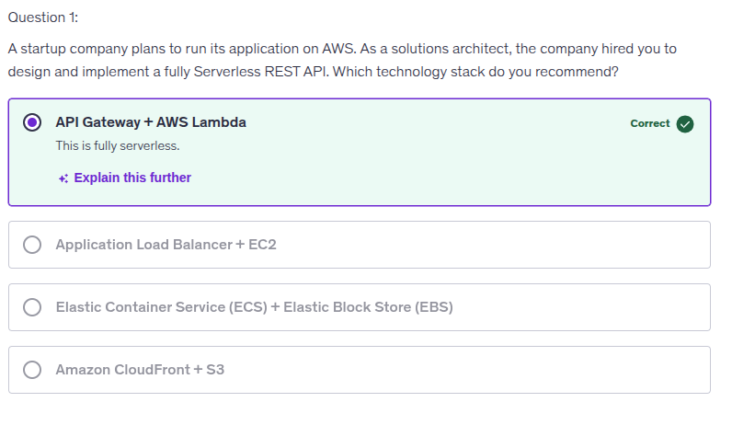

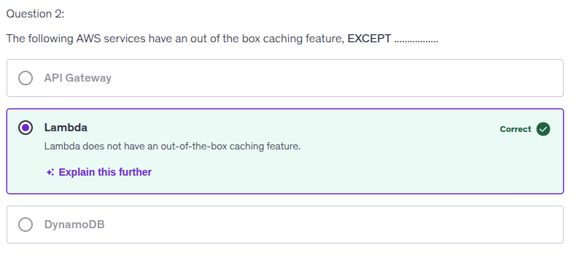

Amazon API Gateway provides caching capabilities for REST APIs. Here are the key features:

How it works:

* When enabled, API Gateway caches responses from your endpoint for a specified time-to-live (TTL) period
* Subsequent requests are served from the cache instead of calling your backend endpoint
* This reduces the number of calls to your endpoint and improves response latency

Key details:

* Default TTL: 300 seconds (5 minutes)
* Maximum TTL: 3,600 seconds (1 hour)
* TTL=0: Disables caching
* Cache capacity: You must choose a cache capacity when enabling (larger capacity provides better performance but costs more)
* Availability: Caching is available for REST APIs only

Configuration:

* Enable caching at the stage level
* By default, caching applies to all GET methods
* You can override cache settings for specific methods
* Use method/integration parameters as cache keys for more granular control Note that caching is best-effort, and creating or deleting a cache takes approximately 4 minutes to complete.

